

|  |  |
| --- | --- |
| **Student Name/ID Number:** | Muhammad Kemal / BDSE07-0922-084 |
| **Academic Year:** | 2023 |
| **Unit Assessor:** | Ei Thandar Khaing |
| **Project Title:** | Power BI Data Preparation and Data Transformation |
| **Issue Date:** | 25-Nov-2023 |
| **Submission Date:** |  |

|  |
| --- |
| **Learner declaration** |
| I certify that the work submitted for this assignment is my own and research sources are fully acknowledged.  Student signature:  Date: |

**Assignment 5:**

1. Load the dataset in Power BI

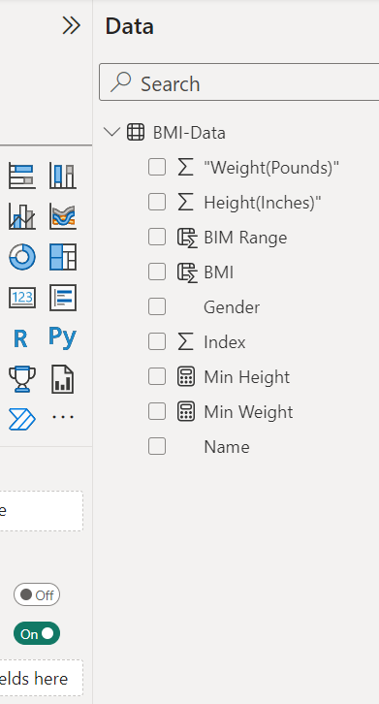

1. Create a new column to calculate the body mass index (BMI) for each individual in the dataset.

• Select the "Data" table and go to the "Modeling" tab.

• Select "New Column" and enter the formula "BMI = [Weight]/POWER([Height]/100,2)".

• Click "OK" to create the new column.

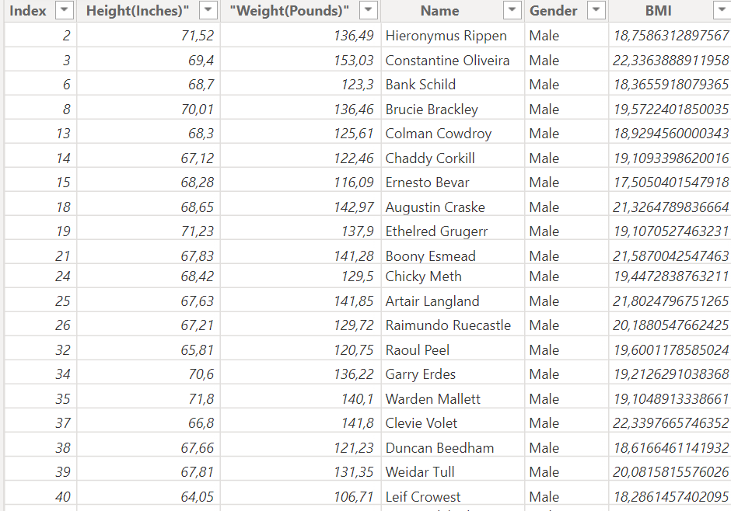

1. Create a pivot table to display the average height and weight by gender.

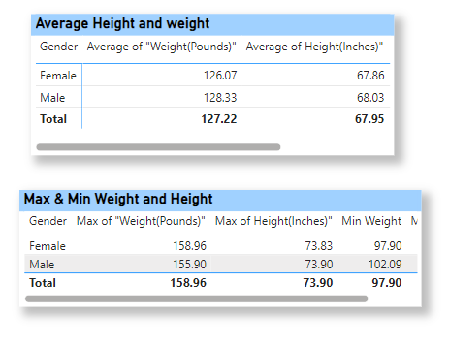

1. Create a chart to display the distribution of BMI in the dataset.

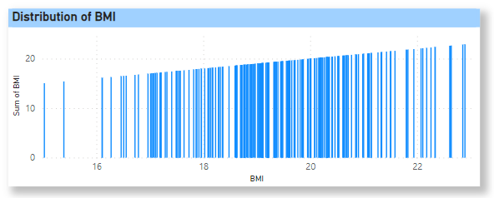

1. Use conditional formatting to highlight the individuals with a BMI over 30.

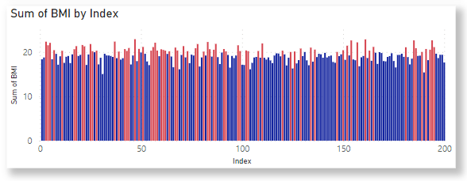

1. Create a new sheet to display the summary of the data, including the average height and weight, the maximum and minimum height and weight, and the number of individuals in the dataset.

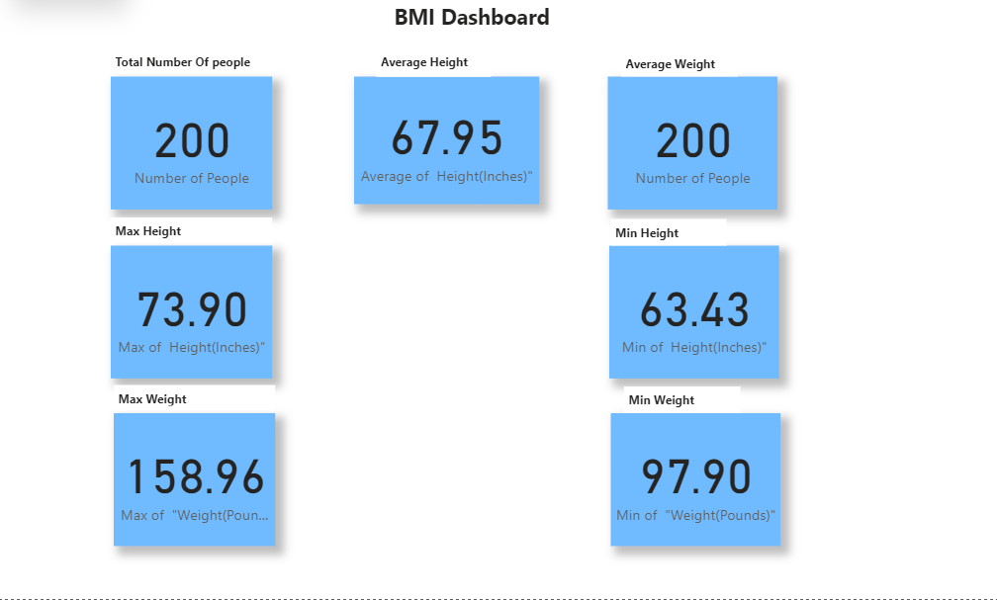

1. Create a calculated column to categorize the individuals in the dataset by BMI range (e.g., underweight, normal, overweight, obese).

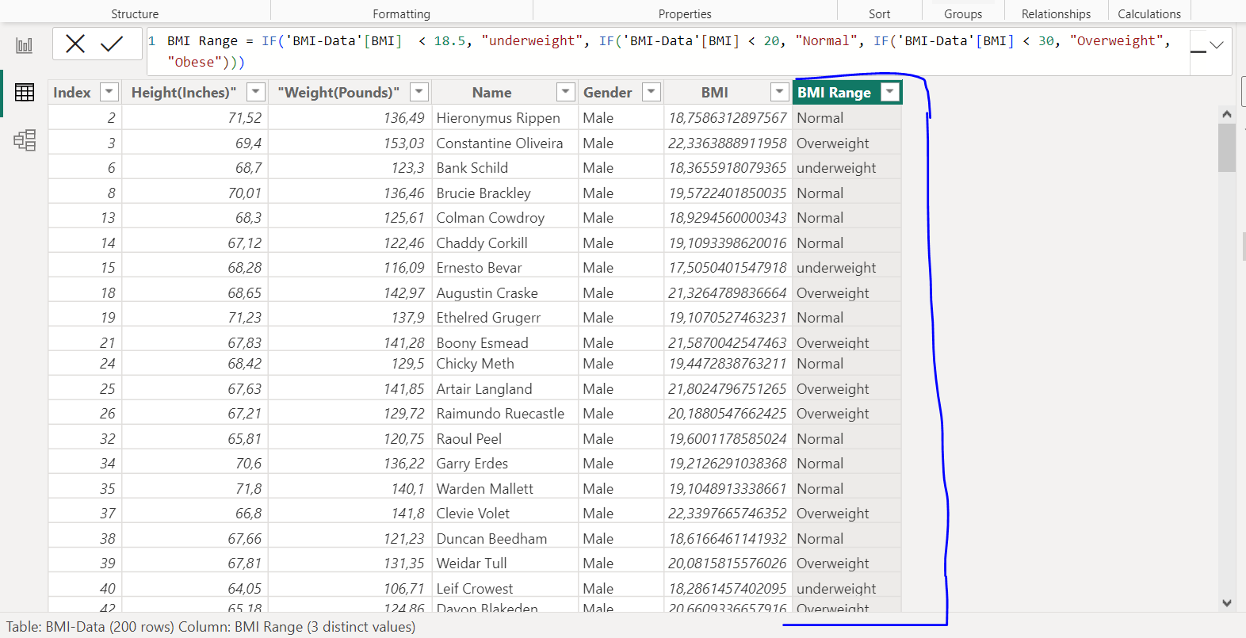

1. Filter the pivot table to show only the individuals with a BMI over 30.

